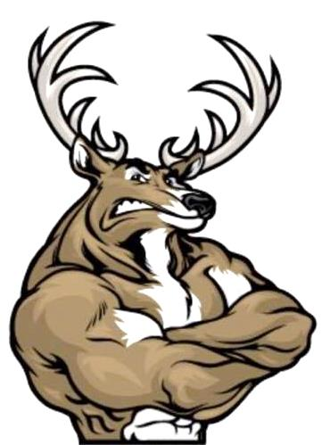
Yankton Youth Wrestling Club
Annual Tournament
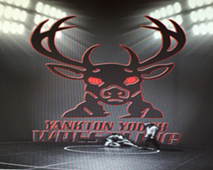
Pic 10 tournament: Trophies for top 3 teams
Sunday, January 5, 2020 Yankton High School 1801 Summit St.
*Girls will wrestle in boys brackets*
Check in: 10 A.M. – NOON Wrestling 12:30 p.m.
(3) 1½ Minute Periods – South Dakota High School Rules
4 Person Round Robin (when possible)
Mail-in Entries & $10 Registration Fee Must Be Received By January 3rd
$5 Coaching Fee: Must Have Coaching Band To Be On Mat
Free with AAU/USA Card
Awards: 1st Place Through 3rd Place Concessions Will Be Served By YYWC – No Coolers Allowed Vendor Blender
**Limited To The First 350 Registered / Absolutely NO Entries At The Door**
MAIL ENTRIES TO: INFORMATION: Yankton Youth Wrestling Club Coach Marshall Bahm 610 Maple Street 605-660-7843 Yankton, SD 57078 or email to: yanktonwrestling@yahoo.com
_ _ _ _ _ _ _ _ _ _ _ _ _ _ _ _ _ _ _ _ _ _ _ _ _ _ _ _ _ _ _ _ _ _ _ _ _ _ _ _ _ _ _ _ _ _ _
PLEASE SEND OR FILL IN ALL INFORMATION SHOWN!
Wrestler Name:____________________________________________Age:____________
Address:____________________________________________________________________
Phone:_________________________Sex:______________Weight:__________________
DOB:_______________________________Years Experience:_____________________
Parent Name:___________________ Parent Signature:________________________

